LOL ESPORTS TOURNAMENT MANAGER
Group Members:
Jade Vincent V. Bernabe
Theodore O. Ruelo
Mitz Anfernee Urfilla
Aem Ortiz Zerrudo
Course, Year & Section:
BS INFO TECH 2C
Mr. Kenny Saylo
Course Instructor
June 25, 2026
LOL ESPORTS TOURNAMENT MANAGER
The League of Legends E-Sports Tournament Manager is a centralized platform designed to manage all League of Legends tournaments throughout the year by organizing teams, players, regions, games, and match results in a structured database system. The system helps tournament organizers maintain accurate and organized records for all tournament-related activities, reducing the difficulty of managing teams, schedules, and game outcomes manually.
The system allows administrators to register teams and player rosters, schedule games with assigned venues and dates, and record match scores and results efficiently for smooth tournament operations. It also supports tracking of player MVP points and maintaining updated tournament records in a centralized database for easy access and monitoring.
This system is intended for tournament organizers, administrators, and esports managers who need a reliable tool to handle tournament operations. It solves common problems such as disorganized team records, difficulty in scheduling matches, delayed result updates, and inaccurate standings computation.
Overall, the League of Legends E-Sports Tournament Manager serves as a practical solution for organizing esports tournaments by improving data accuracy, automating standings and match result updates, and providing a more efficient way to monitor tournament progress throughout the season.
Final Project | Section 3 - ERD (Entity-Relationship Diagram) | DBSYS 1
LOL ESPORTS TOURNAMENT MANAGER ERD
Caption: The figure below shows the Entity-Relationship Diagram of the League of Legends Esports Tournament Manager, including the main entities, their primary keys, foreign keys, and relationships.
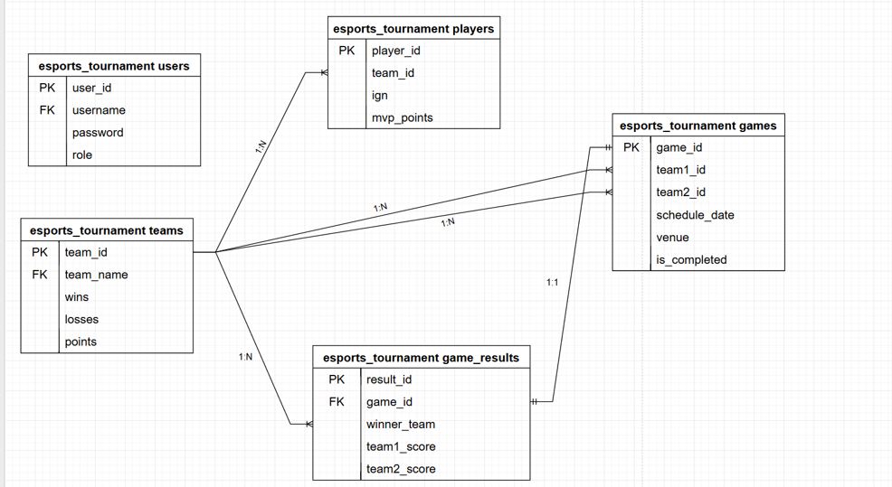
USERS
Field Name | Data Type | Constraints | Description
user_id | INT | PK, AUTO_INCREMENT | Unique identifier for every system user
username | VARCHAR(50) | UNIQUE, NOT NULL | Username used to log in to the system
password | VARCHAR(255) | NOT NULL | Encrypted password of the user
role | ENUM('admin','viewer') | NOT NULL, DEFAULT 'viewer' | User access level in the system
TEAMS
Field Name | Data Type | Constraints | Description
team_id | INT | PK, AUTO_INCREMENT | Unique identifier for each esports team
team_name | VARCHAR(100) | UNIQUE, NOT NULL | Official name of the team or clan
wins | INT | NOT NULL, DEFAULT 0 | Total number of matches won by the team
losses | INT | NOT NULL, DEFAULT 0 | Total number of matches lost by the team
points | INT | NOT NULL, DEFAULT 0 | Total league points earned by the team
PLAYERS
Field Name | Data Type | Constraints | Description
player_id | INT | PK, AUTO_INCREMENT | Unique identifier for each player
team_id | INT | FK → teams(team_id) | Identifies which team the player belongs to
ign | VARCHAR(100) | NOT NULL | In-game name of the player
mvp_points | INT | DEFAULT 0 | Total MVP points earned by the player
GAMES
Field Name | Data Type | Constraints | Description
game_id | INT | PK, AUTO_INCREMENT | Unique identifier for each scheduled game
team1_id | INT | FK → teams(team_id) | First team participating in the match
team2_id | INT | FK → teams(team_id) | Second team participating in the match
schedule_date | DATETIME | NOT NULL | Date and time of the scheduled game
venue | VARCHAR(100) | NOT NULL | Assigned venue or regional tournament server
is_completed | TINYINT(1) | NOT NULL, DEFAULT 0 | Indicates whether the match is finished or pending

GAME_RESULTS
Field Name | Data Type | Constraints | Description
result_id | INT | PK, AUTO_INCREMENT | Unique identifier for each match result
game_id | INT | FK → games(game_id) | References the game being recorded
winner_team_id | INT | FK → teams(team_id) | Identifies the team that won the match
team1_score | INT | NOT NULL, DEFAULT 0 | Final score of team 1
team2_score | INT | NOT NULL, DEFAULT 0 | Final score of team 2

Final Project | Section 5 - SQL Script Summary | DBSYS 1
A. STORED PROCEDURES
Procedure Name: AddUser
Purpose:
The AddUser procedure is responsible for adding a new user to the users table. Before inserting the record, it checks whether a user with the same username already exists in the database. If a duplicate record is found, the insertion is prevented; otherwise, the new user is successfully added.
Input Parameters:
Parameter | Description
p_username | Username of the new user
p_password | Password of the new user
p_role | Role of the user
Output:
Adds a new record to the users table if the username does not already exist.
Procedure Name: AddTeam
Purpose:
The AddTeam procedure is responsible for adding a new team to the teams table. Before inserting the record, it checks whether a team with the same team name already exists. If a duplicate is found, the insertion is prevented; otherwise, the new team is added successfully.
Input Parameters:
Parameter | Description
p_team_name | Official team name
Output:
Adds a new record to the teams table if the team name is unique.
Procedure Name: AddPlayer
Purpose:
The AddPlayer procedure is responsible for adding a new player to the players table. Before inserting the record, it checks whether the same player IGN already exists under the same team. If a duplicate record is found, the insertion is prevented; otherwise, the player is added successfully.
Input Parameters:
Parameter | Description
p_team_id | Team ID of the player
p_ign | In-game name of the player
p_mvp_points | Initial MVP points
Output:
Adds a new player to the players table if the record does not already exist.
Procedure Name: AddGame
Purpose:
The AddGame procedure is responsible for scheduling a new match in the games table. It checks whether the same match between the same two teams is already scheduled at the same date and venue. If a duplicate schedule exists, the insertion is prevented; otherwise, the match is recorded successfully.
Input Parameters:
Parameter | Description
p_team1_id | First team ID
p_team2_id | Second team ID
p_schedule_date | Match schedule date and time
p_venue | Match venue or server
Output:
Adds a new scheduled game to the games table if no duplicate exists.
Procedure Name: AddGameResult
Purpose:
The AddGameResult procedure is responsible for recording the result of a completed game in the game_results table. It stores the winning team and final scores, then updates the participating teams' win/loss records and points in the teams table.
Input Parameters:
Parameter | Description
p_game_id | Game ID being recorded
p_winner_team_id | Team ID of the winner
p_team1_score | Final score of team 1
p_team2_score | Final score of team 2
Output:
Adds a new result to the game_results table and updates team standings automatically.
B. DATABASE VIEW
View Name: TournamentStandingsView
The TournamentStandingsView is responsible for displaying team standings in a simplified format for leaderboard monitoring. It retrieves data from the teams table and presents the current rank-related details such as team name, number of wins, losses, and total points.
Fields Returned:
- team_name
- wins
- losses
- points
Benefits:
- Simplifies leaderboard queries by providing ready-to-display standings data
- Improves readability and consistency across tournament pages
- Makes dashboard reporting faster and easier
- Supports live ranking display for administrators and viewers
C. JOIN Query
Purpose:
Combines match schedule information with team names to display the full game details instead of only team IDs.
Tables Involved:
- games
- teams
Join Type: INNER JOIN
Example Query:
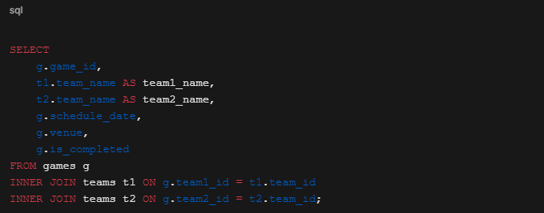
Usage:
Used in the Tournament Match Schedule section of the dashboard to show the scheduled games with team names and venue details.
D. AGGREGATE QUERY
Purpose:
Calculates the total number of MVP points earned by players and displays nomination totals.
Functions Used:
- SUM()
- AS
Example Query:
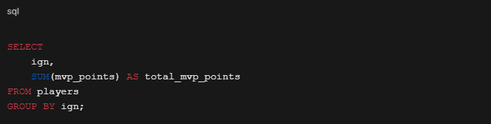
Usage:
Used in the Individual MVP Nominations Tracker to display the total MVP points of each player.
E. SUBQUERY
Purpose:
Displays all teams that currently have at least one win in the tournament standings.
Parent Query:
Retrieves team details from the teams table.
Child Query:
Retrieves all team IDs from the teams table where the number of wins is greater than 0.
Example Query:
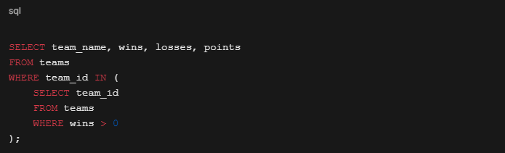
Usage:
Used in reporting and leaderboard filtering to display only teams with winning records.
Final Project | Section 6 - System Screenshots | DBSYS 1
Main Dashboard
The Dashboard provides the administrator with an overview of the League of Legends Esports Tournament Manager. It displays important information such as registered teams, scheduled matches, standings, and MVP nominations. It allows the organizer to manage the tournament efficiently from one main page.
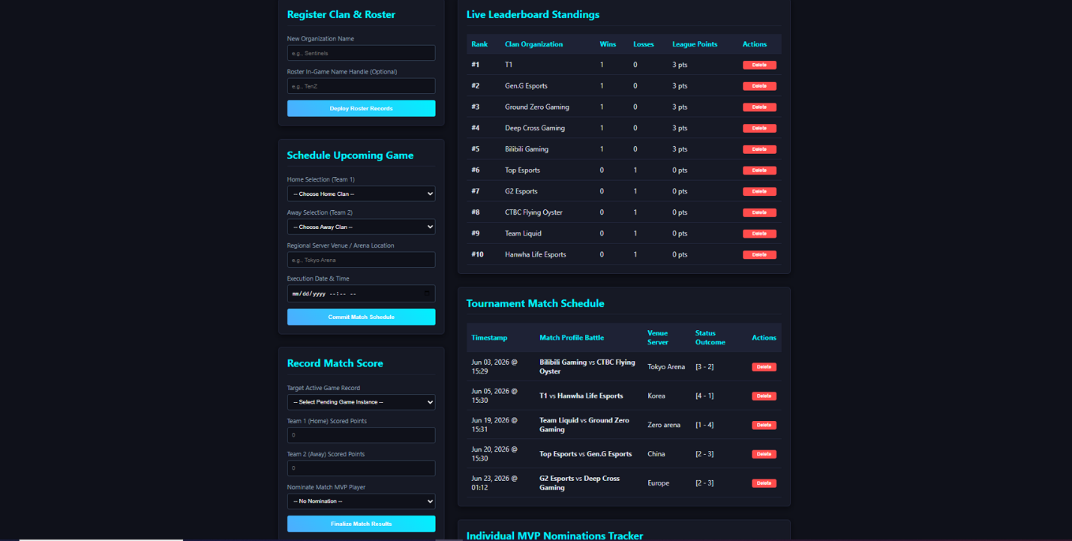
Caption: The main dashboard displays the registration form for teams, match scheduling form, live leaderboard standings, and tournament match schedule.
Dashboard - Match Results and MVP Tracker
This section of the dashboard allows the administrator to record match scores, finalize game results, and monitor player MVP nominations. It supports real-time tournament monitoring and result management.
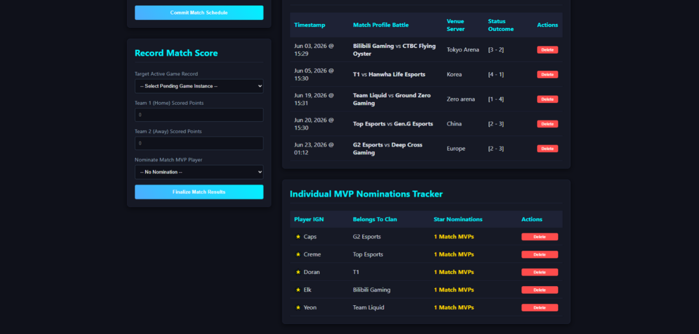
Caption: The dashboard shows the match score recording form, recent tournament match results, and the Individual MVP Nominations Tracker.
phpMyAdmin Database Structure - Users Table
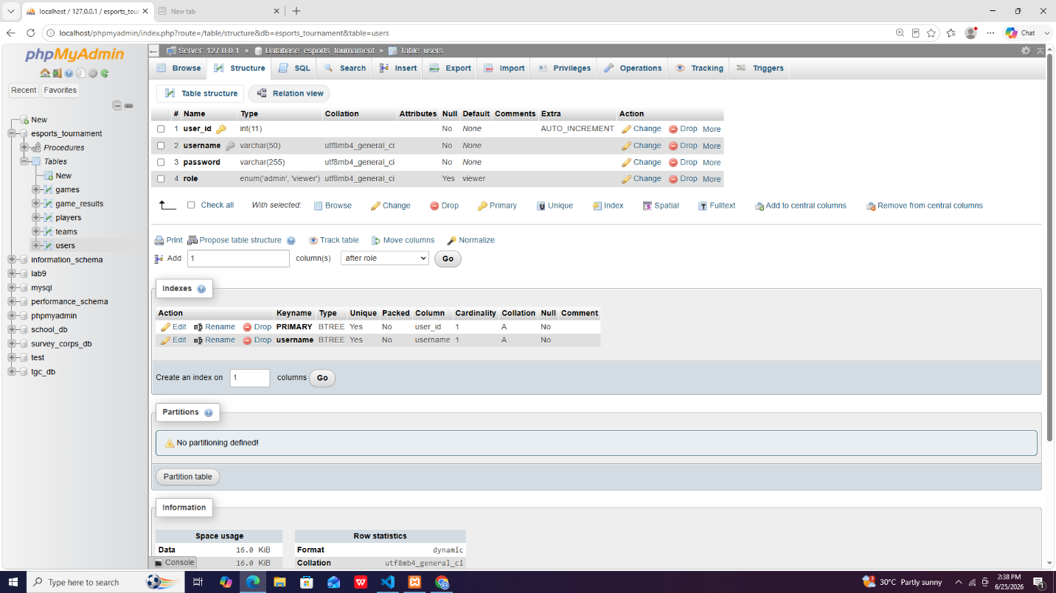
Caption: This screenshot shows the structure of the users table in phpMyAdmin, including the primary key, username, password, and role fields.
phpMyAdmin Database Structure - Teams Table
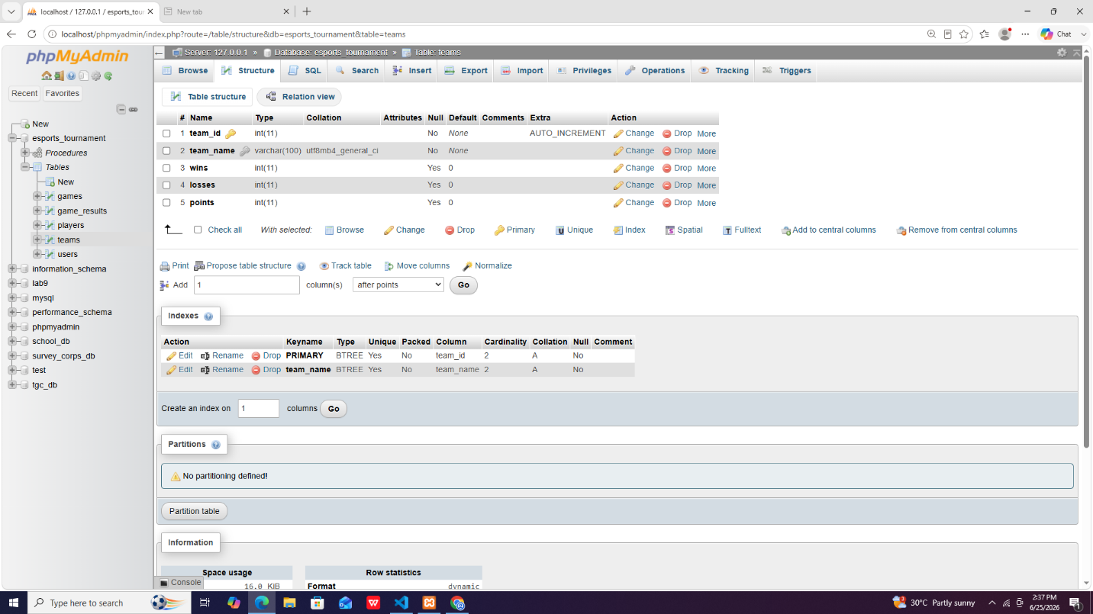
Caption: This screenshot shows the structure of the teams table, including team name, wins, losses, and points.
phpMyAdmin Database Structure - Players Table
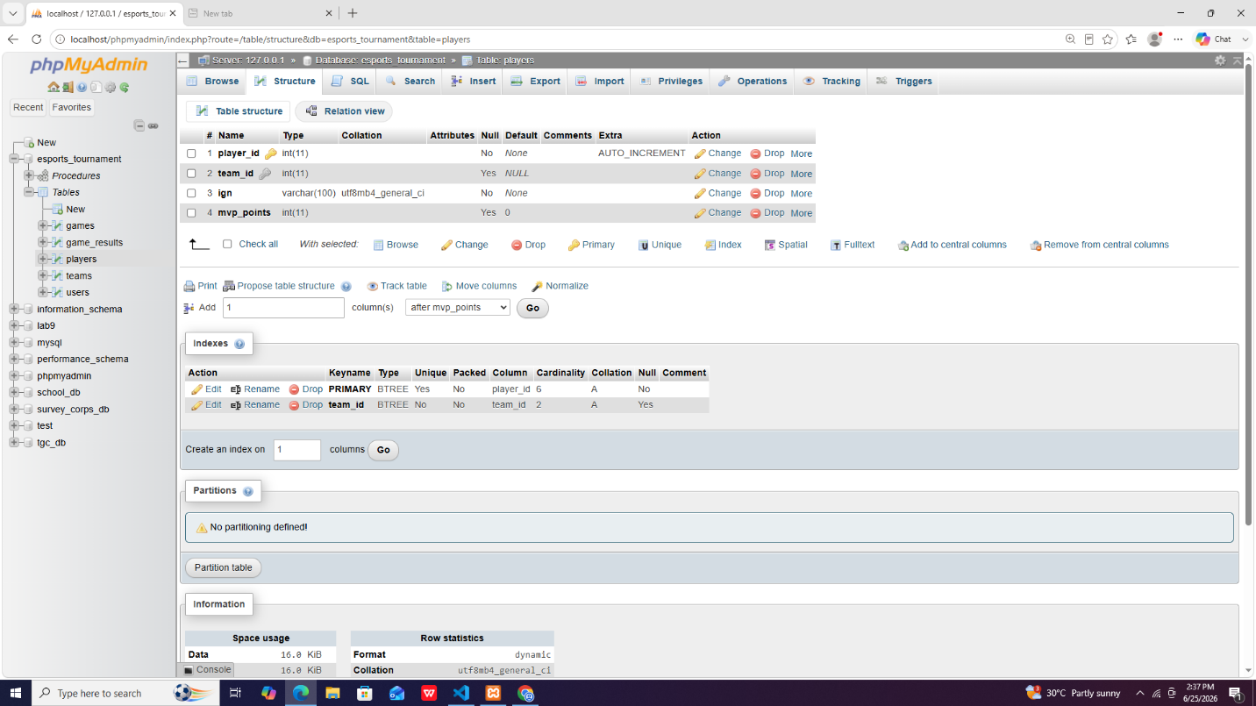
Caption: This screenshot shows the structure of the players table, including the foreign key relationship to teams and the MVP points field.
phpMyAdmin Database Structure - Game Results Table
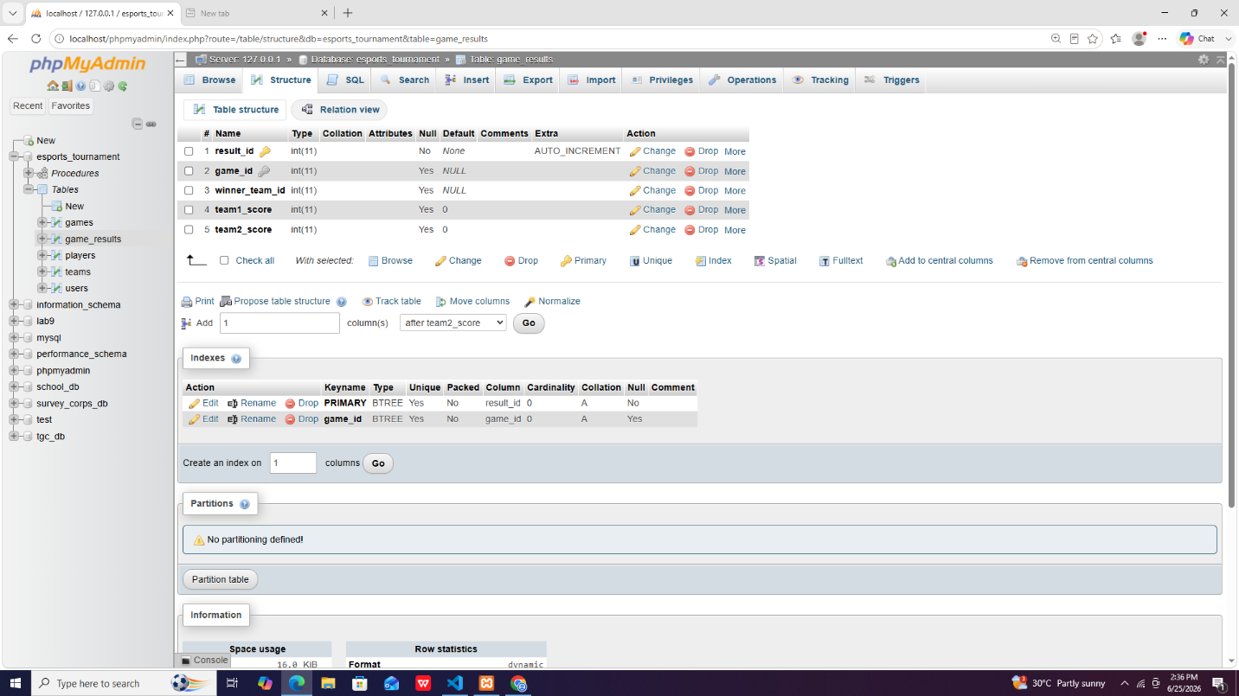
Caption: This screenshot shows the structure of the game_results table, which stores the match result details, scores, and winning team.
phpMyAdmin Database Structure - Games Table
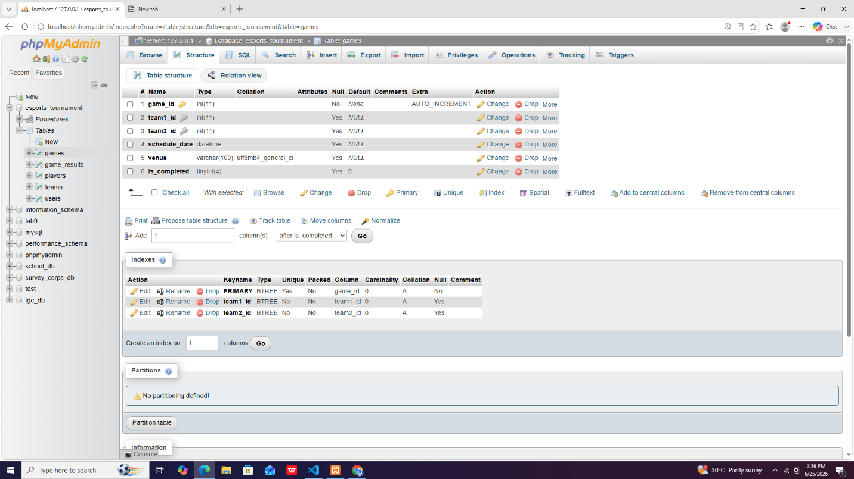
Caption: This screenshot shows the structure of the games table, including participating teams, schedule date, venue, and completion status.
Final Project | Section 7 - System ScreenshotsIndividual Contribution Summary | DBSYS 1

  - Jade Vincent V. Bernabe
I Contributed to the development of the project by helping design the system structure and creating the Entity Relationship Diagram (ERD) to establish the relationships between database tables. I also organized and arranged the tables according to their designated functions to ensure a logical and efficient database design. Additionally, I allocated and populated the SQL seed data, providing the initial records needed for testing and system functionality.
2. Theodore O. Ruelo
During this development cycle, my primary focus was on modifying and refining the application's frontend interface to improve both security presentation and overall user experience. I was responsible for upgrading the Login UI, ensuring that credential pathways clearly differentiate between administrative access and standard viewer restrictions. Additionally, I overhauled the layout of the Main UI Dashboard, restructuring it into an asymmetrical, two-column system that cleanly separates administrative control forms from live data tables. As part of this enhancement, I successfully implemented a real-time JavaScript search filter for the MVP nomination component and introduced dynamic CSS gold highlighting to elevate the visual hierarchy of active tournament earners.
3. Mitz Anfernee Urfilla
I was responsible for the overall database design and architecture of the DBSys system. This started with gathering requirements and translating them into an Entity-Relationship Diagram to model all key entities, relationships, and cardinalities.

4. Aem Ortiz Zerrudo
I Contributed on helping Jade and Mitz creating the database, while my major work was creating the soft copy of our system the documents, compiling the descriptions, parameters, setting up the dashboard . I also did try to connect the front end of the phase 4 part, but I eventually passed it on Theodore since he is more experienced on encoding overall most of us in our group did our part.

